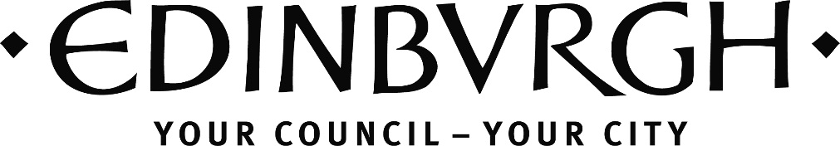
North West Edinburgh
(Almond, Forth, Inverleith and Western Edinburgh)
Community Grants Fund
Application Form (Awards of up to £5,000)

INTRODUCTION
This form has been designed to simplify the Community Grant Fund application process.
Privacy statement: Personal information included on this form will only be used by Council staff for purposes of communication with the applicant and facilitating the transfer of funds if the application is successful. Personal information will not be shared with any third party and will be held for six years from the end of the financial year in which it is submitted, before being destroyed.
Sections 1-4 will be circulated to the relevant decision-making body therefore it is important that the applicant provides accurate details, information about what the grant will be used for and who will benefit.
Section 5-7 will remain confidential in line with GDPR requirements and information such as banking details will only be shared with CEC Finance should the application be successful.
Further information on how the Council manages your personal information and your rights in relation to this is available on the Council website at www.edinburgh.gov.uk/privacy

FOR OFFICE USE:
ON RECEIPT OF APPLICATION
Reference number:
Constitution received?
Accounts received?
Signed copy received?
All estimates received?
Previous grants reported?
AFTER DECISION
Delegated authority form completed if needed:
Acceptance / letter of offer returned:
BACS request form sent off:
End of Grant report reminder in diary:
End of Grant report received:
Please read the accompanying guidance before completing this application.
NAME OF ORGANISATION
Website and/or social media
(if applicable)

Section 1 – Your proposal
1.1 | Please provide a brief overview of your organisation (150 words max):
1.2 | Please provide a brief overview of the proposed project (500 words max):
1.3 | Project dates  (Please note: All funds should be used within twelve months from the date of award)
 | Start Date
 | End Date

Section 2 – Community priorities
2.1 | What needs in the local community does your project aims to address, and what impact do you expect your project to have? (Please refer to the Locality Improvement Plan if applicable)
2.2 | What benefit will the project bring beyond the funding period and how will this be supported?

Section 3– Area and beneficiaries
3.1 | Which geographic communities does your project aims to benefit?
3.2 | How many people does your project aim to benefit?  (Please briefly explain how you arrived at this estimate.)
3.3 | If your project is aimed at specific groups within your community – for example, older or younger people, or people from different ethnic backgrounds – please specify.
3.4 | How have you consulted community members who would benefit from the proposed project?
3.5 | How will you ensure as many people as possible can participate in your project?

Section 4 - Financial Information (Further details can be provided on a separate sheet if required)
4.1 | Please list all project costs  (List costs associated with this specific project only) | Amount | Estimate provided | Date of estimate
 | Total overall cost of project
4.2 | Please list additional funds for this project  (Not including the grant applied for here) | Amount | Funds secured | Date secured
 | Total additional income to project
4.3 | Total amount requested from Community Grant Fund  (Please note: This should be equal to total overall cost minus additional project income)
[Please start new page]
Section 5 - Contact information
5.1 | Name of organisation
5.2 | Name of main contact
5.3 | Name of alternate contact (optional)
5.4 | Contact postal address
5.5 | Contact phone number
5.6 | Contact email address
5.7 | Charity/SCIO Number (if applicable)
5.8 | Company Number (if applicable)
5.9 | VAT Number (if applicable)
5.10 | How many people does your organisation employ?
 | None
 | 1 to 9
 | 10 to 49
 | 50 to 249
 | Over 250
5.11 | Bank details  Please state the name of the bank account this grant would be paid into if successful. (This should be the bank account of the organisation stated above.)
 | Name of bank
 | Bank address
 | Account name
 | Bank sort code
 | Account number

Section 6 – Confirmation and declarations
CONFIRMATIONS | Please tick
I confirm I have obtained all necessary consents, insurance, and permissions to carry out the project. | ☐
If you work with vulnerable groups, please confirm that you have relevant policies in place, and state which ones, for example Child Protection, below | ☐
I confirm that the following documents have been included with this application: | Please tick
Constitution or Memorandum and Articles of Association, Trust Deeds of your organisation | ☐
Most recent annual (audited) accounts. Where your organisation is newly constituted, a most recent bank statement will suffice. | ☐
Evidence of all estimates / quotations listed in section 4 (any comments or clarifications please state here): | ☐

Section 7 - SIGNATURES
All applications must be signed by two people who are recognised as representatives of your organisation. Signatories must be individuals authorised to enter into agreements and receive funds on behalf of your organisation.
You are being asked to declare that:
- You have read and will comply with all City of Edinburgh Council funding conditions.
- To the best of your knowledge, that the information contained in this application and any accompanying attachments is accurate.

Name (1):
Date:
Position:
Signature:

Name (2):
Date:
Position:
Signature:

Please send applications for Almond / Forth / Inverleith or Western NN and accompanying documents to: elaine.lennon@edinburgh.gov.uk

